


SAVEETHA INSTITUTE OF MEDICAL AND TECHNICAL SCIENCES (SIMATS)
Saveetha School of Engineering
Department of Computer Science and Engineering

SOFTWARE ENGINEERING
Architecture Design
TITLE : Design and Development of an Online Auction System with Real-Time Bidding

Submitted By
Name : Akileshwaran A
Register Number : 192511354
GUIDED BY

Course Faculty : Dr. K. ANITADAVAMANI

SIMATS ENGINEERING
Saveetha Institute of Medical and Technical Sciences Chennai - 602105
july- 2026

TABLE OF CONTENTS
s.no | content | Pg.no
1. | System Requirements | 3
2. | Software Architecture for the Online Auction System with Real-Time Bidding | 6
3. | Architecture Diagram | 7
4. | Components and Interactions of the Online Auction System with Real-Time Bidding | 8
5. | Quality Attribute Analysis of the Online Auction System with Real-Time Bidding | 10
6. | Architectural Justification for the Online Auction System with Real-Time Bidding | 12
ONLINE AUCTION SYSTEM WITH REAL-TIME BIDDING

Architecture Design Report

1. Online Auction System with Real-Time Bidding – System Requirements

1.1 Introduction
The Online Auction System with Real-Time Bidding is a web-based platform that enables buyers and sellers to participate in auctions through the internet. Sellers can publish products for auction by specifying product information, starting price and auction duration. Buyers can browse products and place bids while an auction is active.
Real-time bidding is the central feature. When a valid bid is submitted, the system validates it, updates the highest bid and communicates the updated auction information to participating users. When the auction ends, the system stops accepting bids and identifies the highest valid bidder as the winner.

1.2 Objectives
- Provide a secure online platform for conducting auctions.
- Allow sellers to create and manage auction listings.
- Allow buyers to browse products and participate in live bidding.
- Process and validate bids accurately in real time.
- Automatically identify the winning bidder when an auction ends.
- Support secure online payment and transaction processing.
- Provide notifications for important auction events.
- Provide administrative control over users, products and auctions.

1.3 Functional Requirements

User Registration and Authentication
Users can register, log in, log out, update profiles and recover account credentials. Authentication protects restricted functions.

Seller and Auction Listing Management
Sellers can create listings with product details, images, starting price and auction duration, and manage eligible listings.

Product Search and Viewing
Buyers can search products, view details, current highest bid and remaining auction time.

Real-Time Bidding
The system accepts valid bids during the active period, checks bidding rules and updates the highest bid with minimal delay.

Auction Completion
When the timer expires, the system stops accepting bids, records the highest valid bid and declares the winner.

Payment and Transaction Management
The system supports secure payment after an auction is won and records payment status and transaction information.

Notifications
Users receive alerts for successful bids, being outbid, winning an auction, auction completion and payment confirmation.

Administration
Administrators can manage users, monitor listings and auction activity, and handle operational issues.

1.4 Non-Functional Requirements
Requirement | Description
Performance | Bid requests should be processed quickly and current auction information should be displayed with minimal delay.
Security | Authentication, authorization, secure communication and protected payment processing should safeguard information.
Scalability | The system should support growth in users, products, auctions and simultaneous bidding.
Reliability | Valid bids and auction results should be processed consistently without incorrect winner selection.
Availability | The service should remain accessible with minimal downtime.
Maintainability | Modular components should make testing, debugging and future changes easier.

1.5 Quality Attributes

Scalability
The architecture should accommodate increasing users and concurrent auctions. Services can be separated logically so heavily used functions can receive additional resources.

Security
The system should protect accounts, personal information, bidding data and payment-related information through authentication, authorization and secure communication.

Performance
Real-time bidding requires low response time. Efficient service processing and database operations should provide fast bid updates.

Reliability
The system should maintain correct auction state, reject invalid bids and prevent bids after an auction has closed.

Maintainability
Separating presentation, control, business services and data storage reduces coupling and makes updates easier.

Availability
Reliable hosting, monitoring, backup and recovery mechanisms can reduce downtime.

2. Software Architecture for the Online Auction System with Real-Time Bidding

2.1 Selected Software Architecture
The selected architecture is a Hybrid Architecture combining Model–View–Controller (MVC) with Client–Server Architecture. MVC separates the user interface, control logic and application data. Client–Server architecture provides centralized processing and data management for multiple users.

2.2 MVC Structure
The View represents the web or mobile interface. The Controller receives requests, routes them to appropriate services and returns responses. The Model represents application data and business entities such as users, products, auctions, bids and payments.

2.3 Client–Server Structure
Users access the system through client applications. Requests are sent to server-side services that process authentication, auction rules, bidding, payment and notifications. Centralized processing helps maintain consistent auction information.
2.4 Suitability of the Architecture
The hybrid architecture is suitable because an online auction system has several responsibilities that should be separated. The user interface should not directly implement auction rules or database operations. Requests pass through controllers and services where business rules are applied.
The design also supports multiple clients. A web browser and a future mobile application can use the same server-side services, reducing duplication of business logic.

2.5 Benefits for Real-Time Bidding
- Centralized bid validation applies consistent bidding rules.
- The Auction Service can maintain current auction state and highest valid bid.
- Real-time communication can distribute bid updates to connected clients.
- The database provides persistent auction and bidding history.
- Individual services can be optimized as demand increases.
- Future web and mobile clients can reuse the same backend.

3. Software Architecture Diagram of the Online Auction System with Real-Time Bidding
Create the architecture diagram using an online diagramming tool such as Lucid Chart (diagrams.net). The diagram should show users, client interface, MVC layers, application services, database and external services.
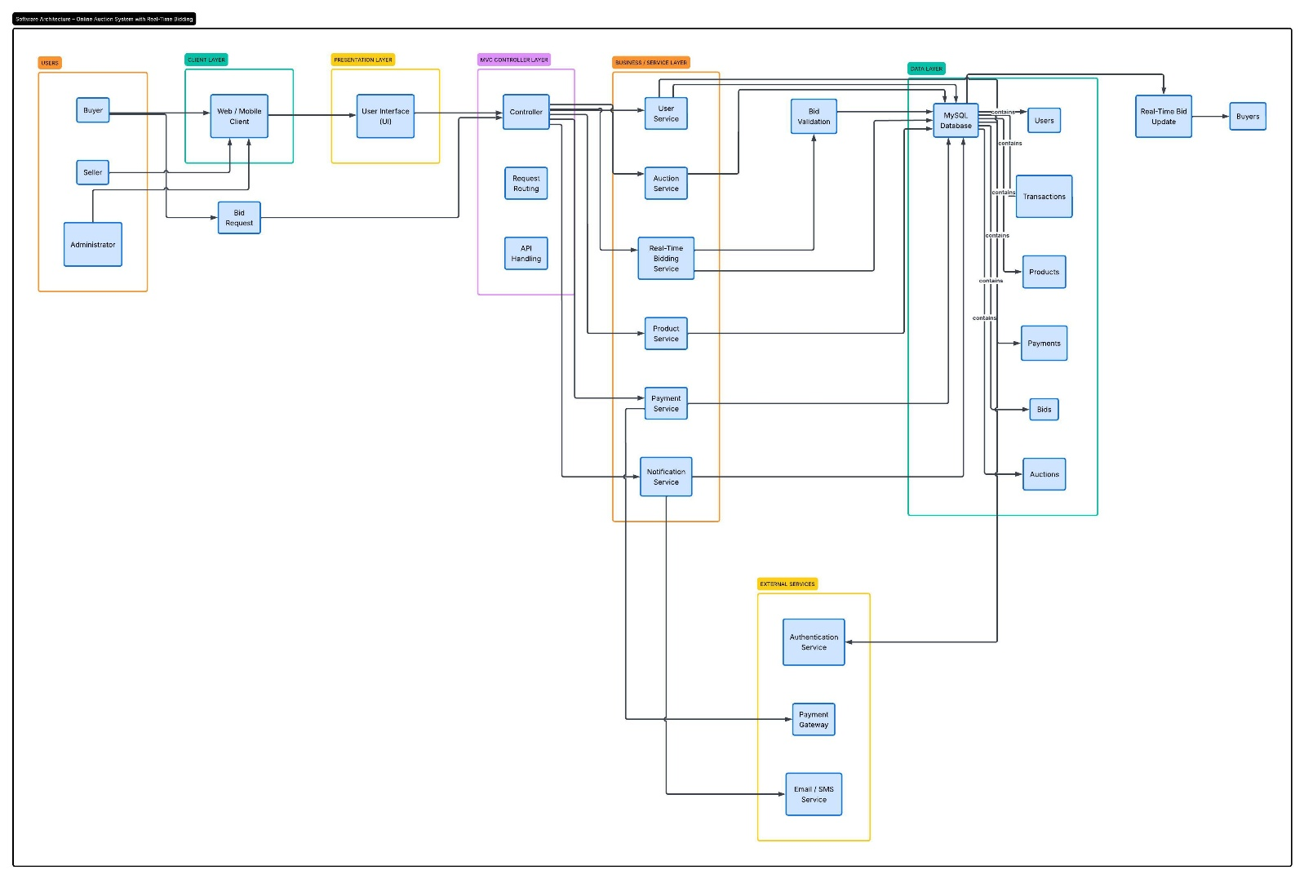

3.1 Main Communication Flow
Buyer, Seller and Admin users access the Web/Mobile Client. The client communicates with the Presentation Layer. Requests move to the Controller Layer and then to the required service. Services read or write data in MySQL and communicate with external payment or notification services when required.

4. Components and Interactions of the Online Auction System with Real-Time Bidding

4.1 Buyer Component
Represents users who browse listings and participate in bidding. Buyers can view product information, current bids, timers and bidding history.

4.2 Seller Component
Represents users who create and manage auction listings, including product information, starting prices and durations.

4.3 Admin Component
Provides authorized administrative functions such as user management, auction monitoring and listing review.

4.4 Web/Mobile Client
Provides the interface used by buyers, sellers and administrators to view information and perform operations.

4.5 Presentation Layer
Handles the user-facing MVC component and sends user actions to the Controller Layer.

4.6 Controller Layer
Handles request routing and API communication. It validates request flow and forwards operations to appropriate services.

4.7 User Service
Handles registration, profiles, user roles and user-related operations.

4.8 Auction Service
The core business component for real-time bidding. It validates bids, updates highest bids, manages auction timing and determines winners.

4.9 Product Service
Manages product information, categories, images and listing status.

4.10 Payment Service
Manages payment operations after an auction is won and communicates with the Payment Gateway.

4.11 Notification Service
Sends important events such as bid confirmation, outbid alerts, winner notifications and payment reminders.

4.12 Authentication Service
Verifies user identity and supports protected access.

4.13 MySQL Database
Stores users, products, auctions, bids, payments and transaction history.

4.14 Payment Gateway
Represents the external service used to process or verify online payments.

4.15 Email/SMS Service
Represents an external service used to deliver notifications.

4.16 Component Interaction
A user action begins at the client. The Presentation Layer sends the request to the Controller Layer, which routes it to the required service. For a bid, the Auction Service validates the bid, updates auction data and triggers real-time and notification updates. For a completed auction, the winner is recorded and the Payment Service can initiate payment.

4.17 Overall System Workflow
- User registers or logs in.
- Seller creates an auction listing.
- Buyer searches and opens an active auction.
- Buyer submits a bid.
- Controller routes the bid to the Auction Service.
- Auction Service validates and records the new highest bid.
- Updated bid information is sent to participating clients.
- Auction remains active until its scheduled end.
- Highest valid bidder is declared the winner.
- Payment is initiated and verified.
- Notifications and transaction records are updated.

5. Quality Attribute Analysis of the Online Auction System with Real-Time Bidding

5.1 Scalability
An online auction platform may experience high traffic during popular auctions. Separating the interface and services allows server resources to be increased as demand grows. The Auction Service can receive additional resources because bidding generates frequent requests.

5.2 Security
Authentication verifies identity and authorization controls access according to buyer, seller and administrator roles. Secure communication should protect data in transit. Payment processing should use a secure payment service.

5.3 Performance
Bid requests should be processed quickly so users receive current auction information with minimal delay. Efficient routing, optimized database operations and real-time communication can improve response time.

5.4 Reliability
The Auction Service should validate each bid, maintain consistent auction state and prevent bids after closure. Logging and error handling help identify and recover from failures.

5.5 Maintainability
MVC separation and modular services make it easier to modify the interface, auction rules, payment functions or notification functions without changing the entire system.

5.6 Availability
Availability ensures that buyers and sellers can access auctions when needed. Reliable hosting, monitoring, backups, recovery procedures and suitable deployment strategies can support continuous service.

5.7 Quality Attribute Summary
Quality Attribute | Architecture Support | Expected Benefit
Scalability | Separate services and scalable resources | Supports growth in users and auctions
Security | Authentication, authorization and secure communication | Protects users and transactions
Performance | Efficient services and real-time communication | Fast bid processing and updates
Reliability | Validation and consistent auction state | Accurate bids and winners
Maintainability | MVC separation and modular services | Simpler updates and debugging
Availability | Reliable deployment, backup and recovery | Reduced downtime

6. Architectural Justification for the Online Auction System with Real-Time Bidding

6.1 Architectural Decisions
The first major decision is to separate presentation from business logic using MVC. The second is to use Client–Server architecture so multiple users can access centralized services and consistent auction data. The Auction Service is treated as a core business component because real-time bid validation and auction completion are critical.

6.2 Advantages
- Clear separation of responsibilities.
- Centralized and consistent auction processing.
- Support for concurrent users.
- Improved maintainability and testing.
- Better security and authorization control.
- Integration with external payment and notification services.
- Flexibility for future web and mobile clients.

6.3 Architectural Trade-Offs
The hybrid architecture provides strong separation and flexibility but introduces additional design and implementation complexity. Multiple layers and services require careful interface design and testing. Real-time communication requires attention to concurrency, connection management and consistent auction state.
Decision | Advantage | Trade-Off
MVC separation | Better organization and maintainability | More layers to develop and manage
Client–Server | Centralized processing and shared data | Server is an important dependency
Real-time bidding | Immediate auction updates | Requires concurrency handling
External payment service | Specialized secure payment processing | Depends on external service
Notification service | Fast user alerts | Requires messaging integration

6.4 Future Enhancements
- Dedicated mobile application using the same backend services.
- AI-based product recommendations.
- Advanced auction analytics and dashboards.
- Additional payment gateways.
- Multi-language and multi-currency support.
- Fraud and suspicious bidding detection.
- Cloud deployment with automatic scaling.
- Enhanced live-auction features.

6.5 External System Integration
The architecture supports external systems through service interfaces. Payment processing can use a payment gateway, while Email/SMS services can deliver notifications. Additional services can be introduced later without directly changing the presentation layer.

6.6 Overall Architectural Suitability
The Hybrid MVC + Client–Server architecture is suitable because it separates user interaction from application logic and centralized data management. It supports accurate and timely bidding while providing a structured foundation for security, scalability, reliability and future enhancement.

6.7 Conclusion
The Online Auction System with Real-Time Bidding provides a digital solution for conducting auctions in which buyers and sellers interact through a secure online platform. The architecture must support real-time bid processing, accurate auction completion, secure transactions and reliable data management.
The selected Hybrid MVC + Client–Server Architecture provides a suitable structure for these requirements. MVC separates presentation, control and model responsibilities, while Client–Server architecture allows multiple users to access centralized application services and data. The Auction Service provides the core real-time bidding functionality, while User, Product, Payment, Notification and Authentication Services support the surrounding operations.
The architecture addresses important quality attributes. Scalability supports growth, security protects users and transactions, performance supports timely bid updates, reliability helps maintain correct auction results, maintainability simplifies future changes, and availability supports continuous access.
Overall, the proposed architecture provides a clear and practical foundation for implementing the Online Auction System with Real-Time Bidding. It can be extended with mobile applications, AI-based recommendations, advanced analytics, additional payment options and cloud-based scaling while maintaining the same core architectural principles.

